**ANALYSING HOUSING PRICES IN METROPOLITAN AREAS OF INDIA**

1. INTRODUCTION

The analysis of housing prices in the metropolitan areas of India is a crucial endeavor with far-reaching implictions for individuals,investors,developers, and policymarkers. In a nation characterized by its diverse culture, economic dynamism, and rapid urbanization, understanding the dyamics of real estate markets of paramount importance.

* 1. **Overview**

**Gather housing price data for the specific metropolitan areas you are interested in. This data can be obtained from real estate websites, government records, property listings, and real estate agencies. Ensure the data is comprehensive and up-to-date.**

* 1. **purpose**
* **Identify and select relevant features that may impact housing prices, such as location, property size, number of bedrooms, amenities, and more.**
* **Create new features if needed, like price per square foot or distance to key landmarks**

1. **Problem Statement & Desing Thinking**

**Consider the policy implications of your analysis. Your findings may inform urban planning, real estate investment decisions, and government policies related to affordable housing and urban development.**

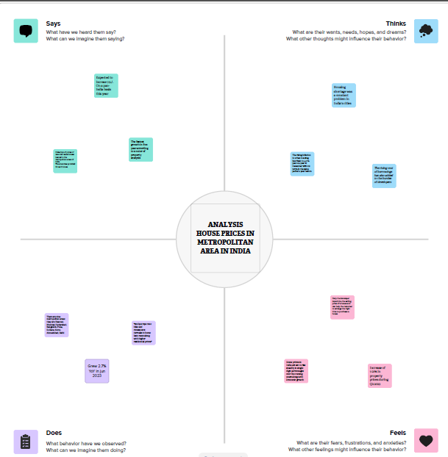

**2.2**

**EMPATHY MAP**

**2.3**

**IDEATION**

**&**

**BRAINSTROMING**

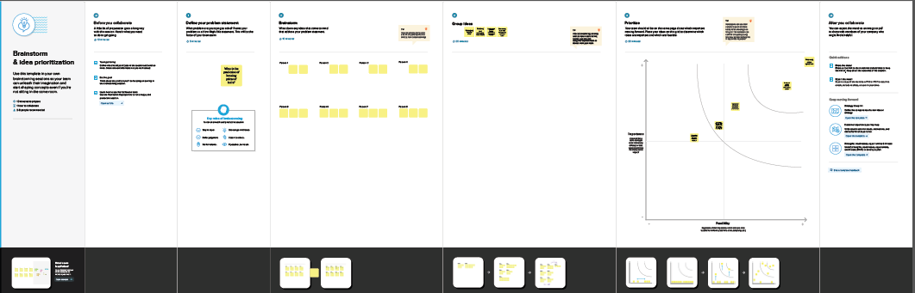

1. **RESULT**

DATA PRESENTATION

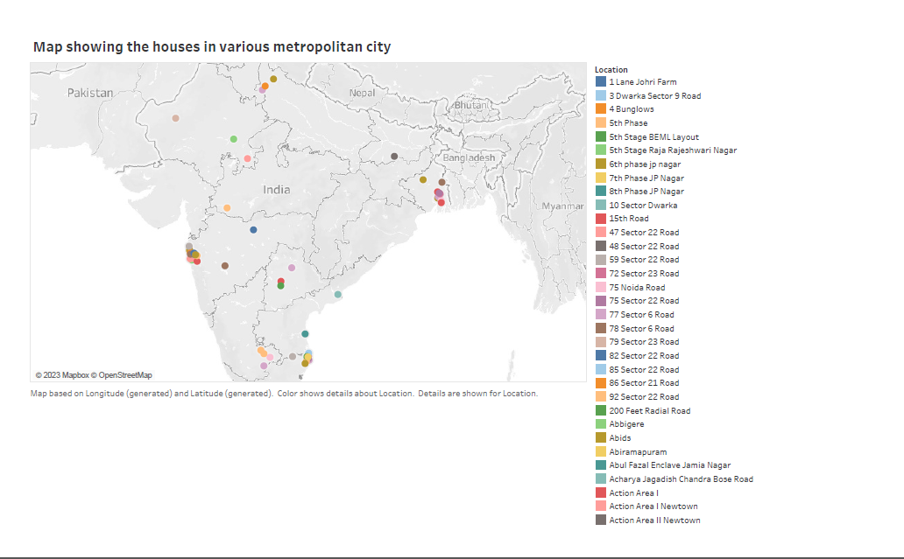

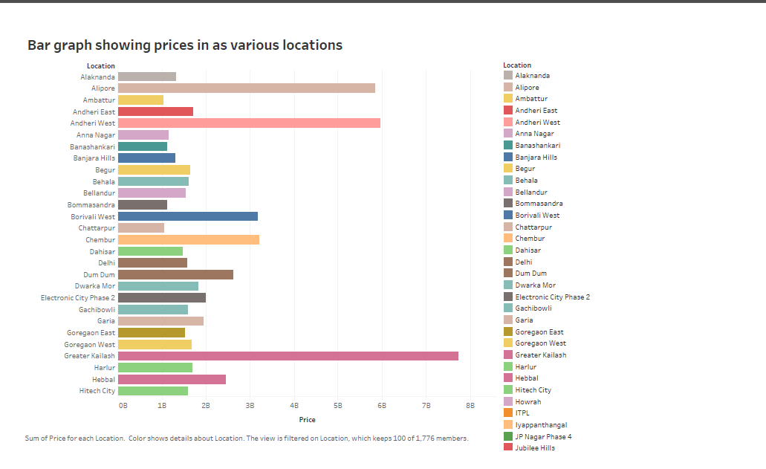

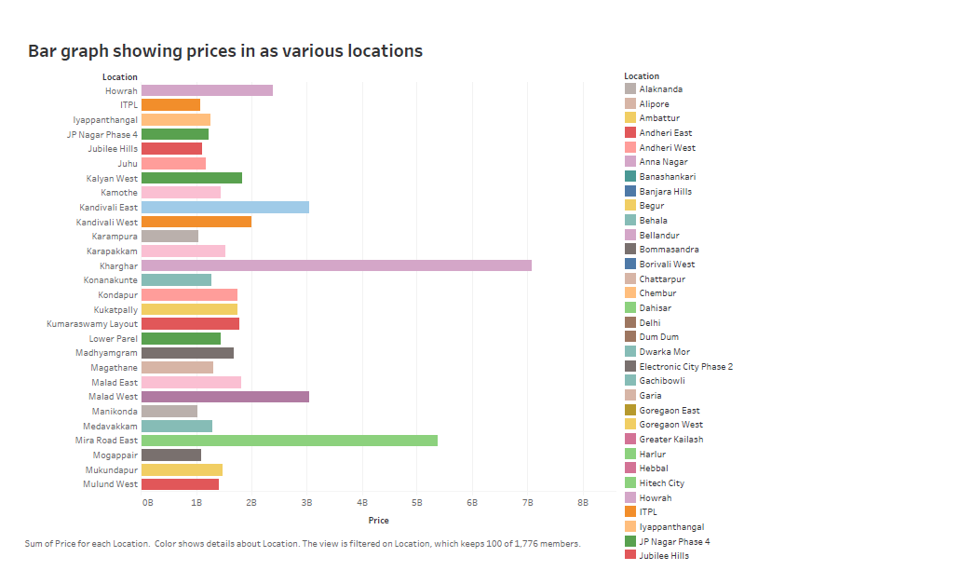

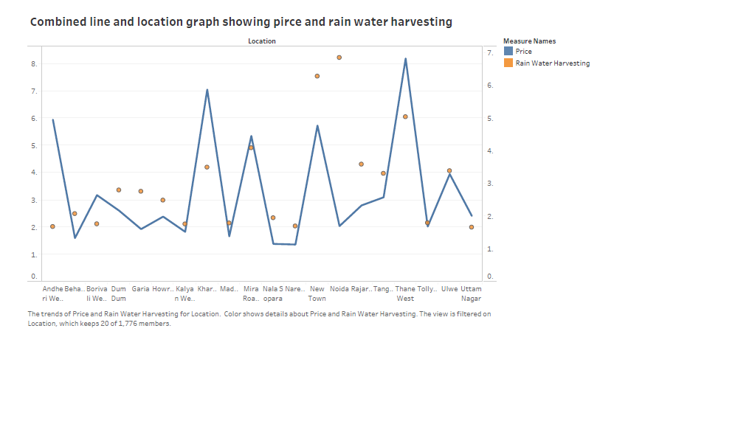

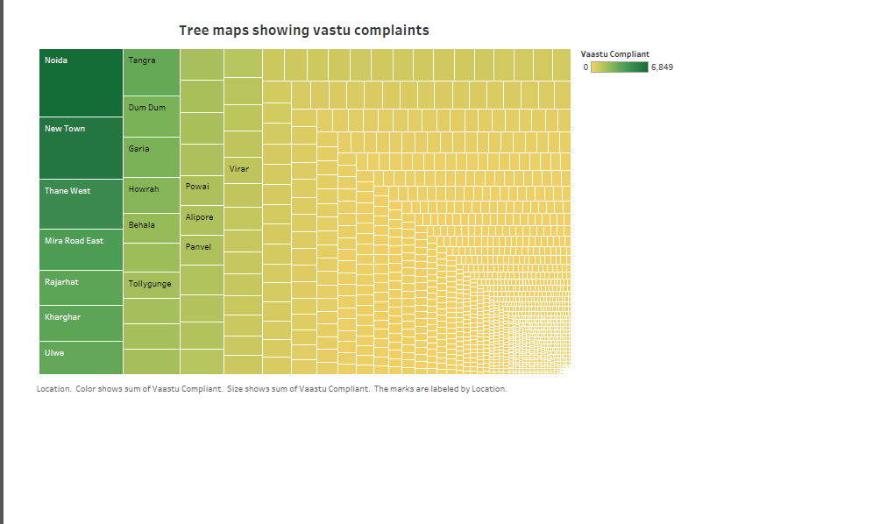

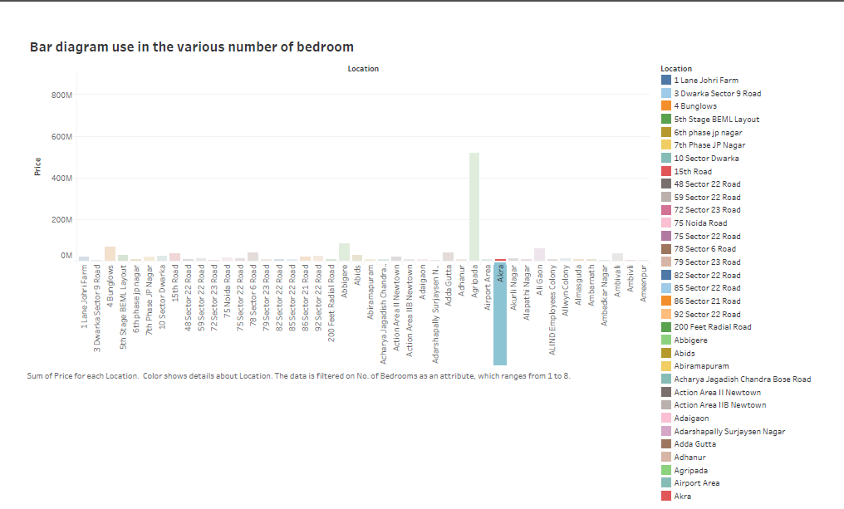

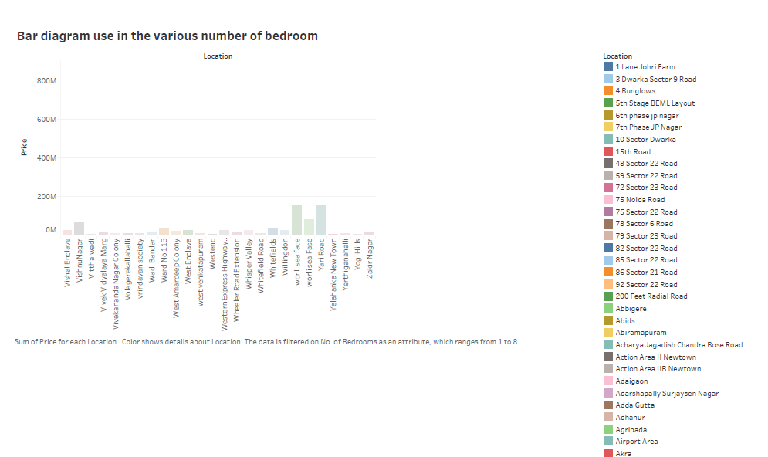

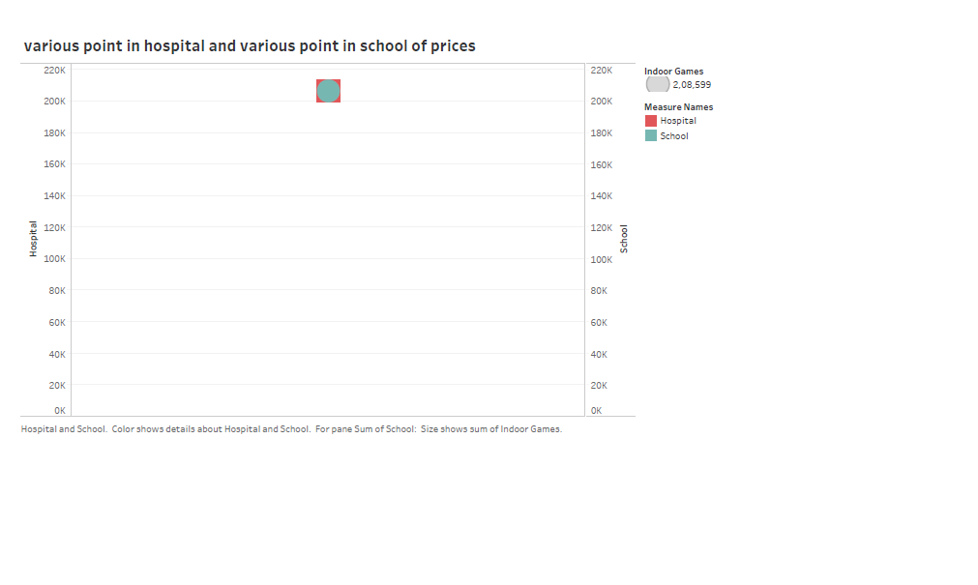

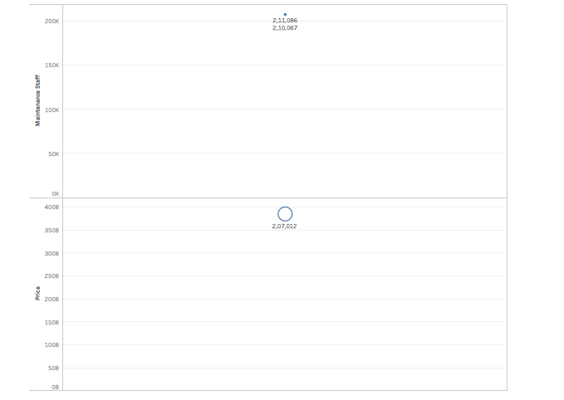

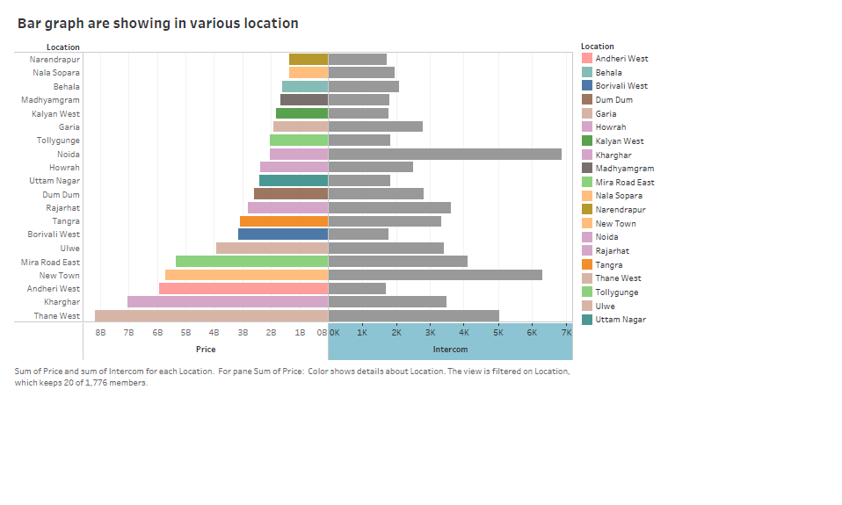

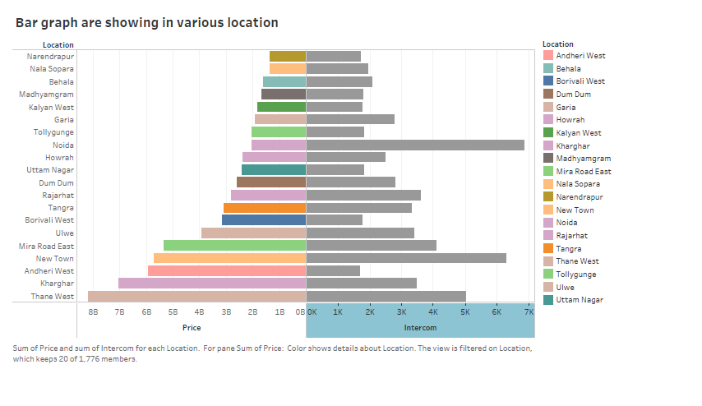

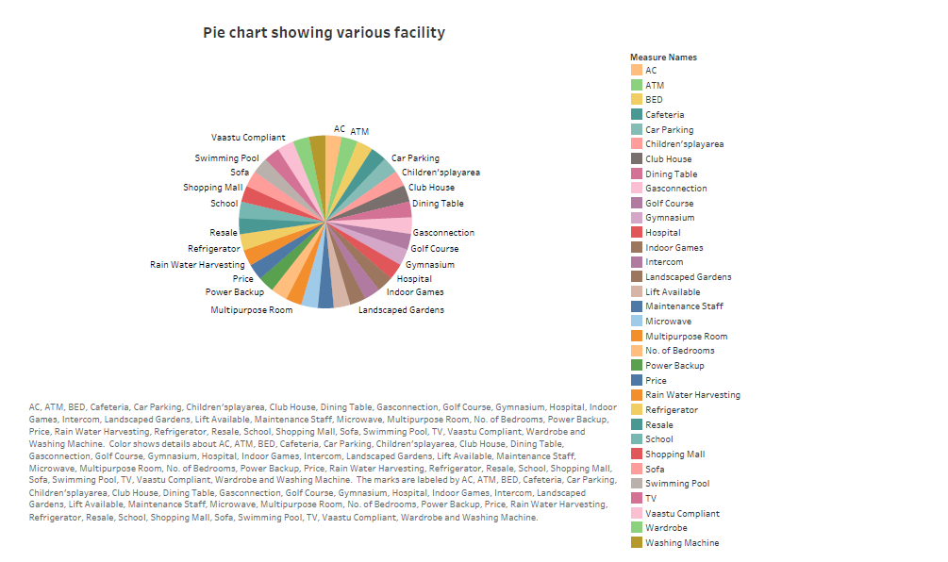

DASHBOARD 1

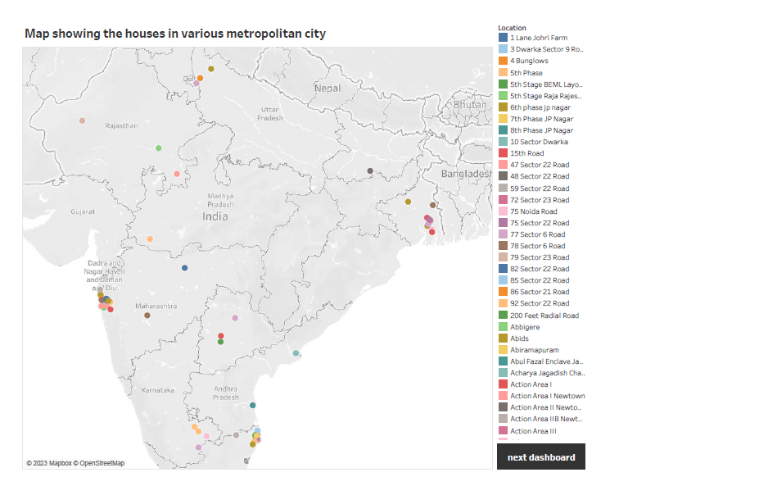

DASHBOARD 2

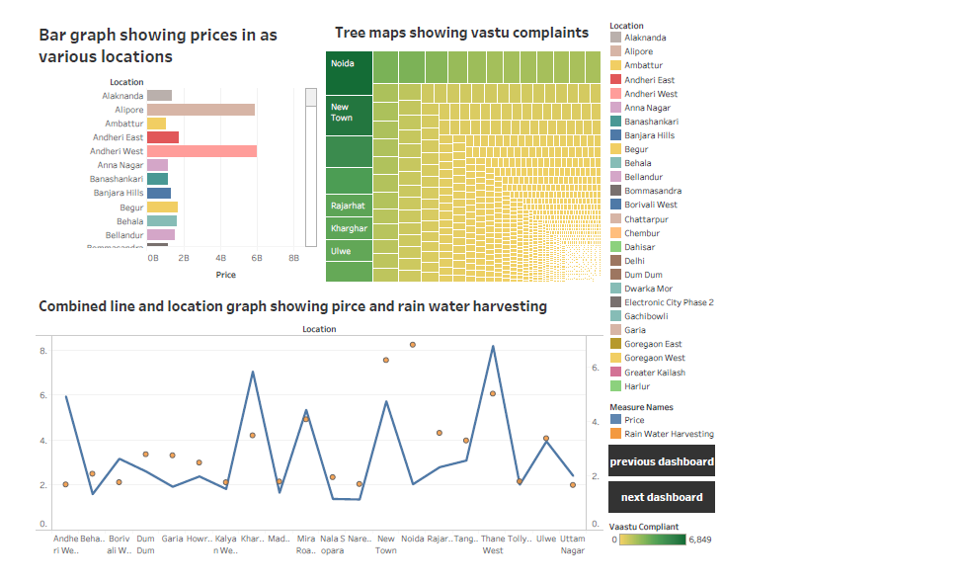

DASHBOARD 3

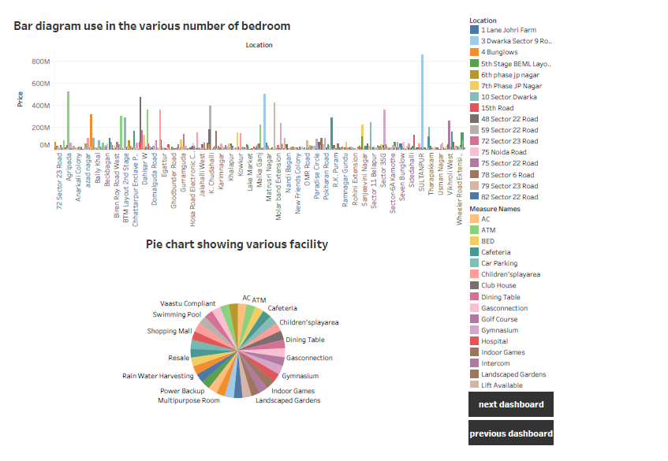

DASHBOARD 4

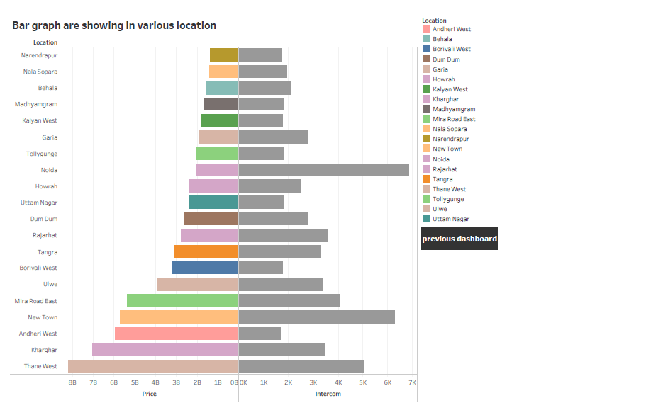

STORY 1

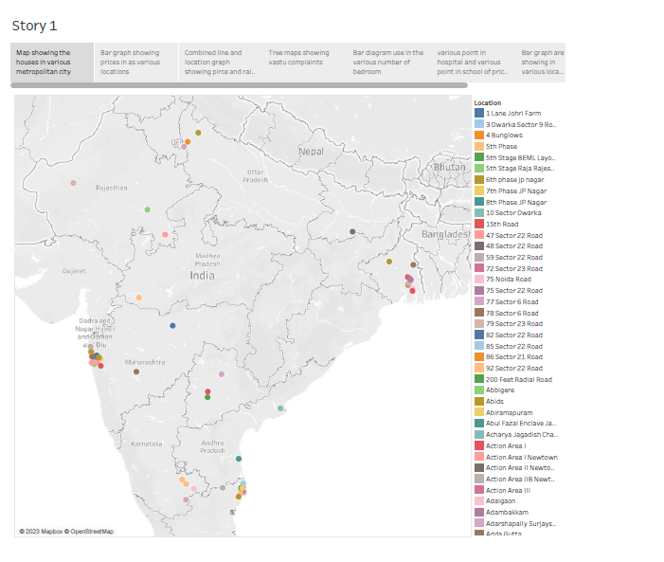

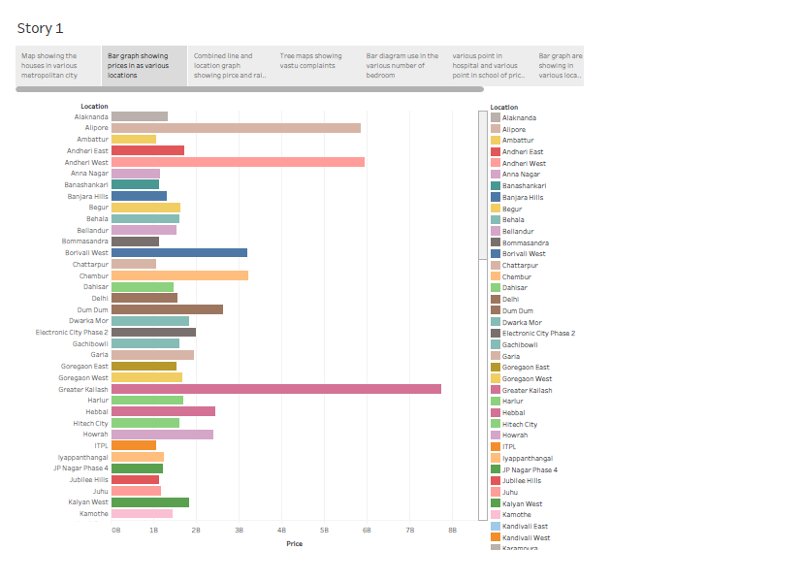

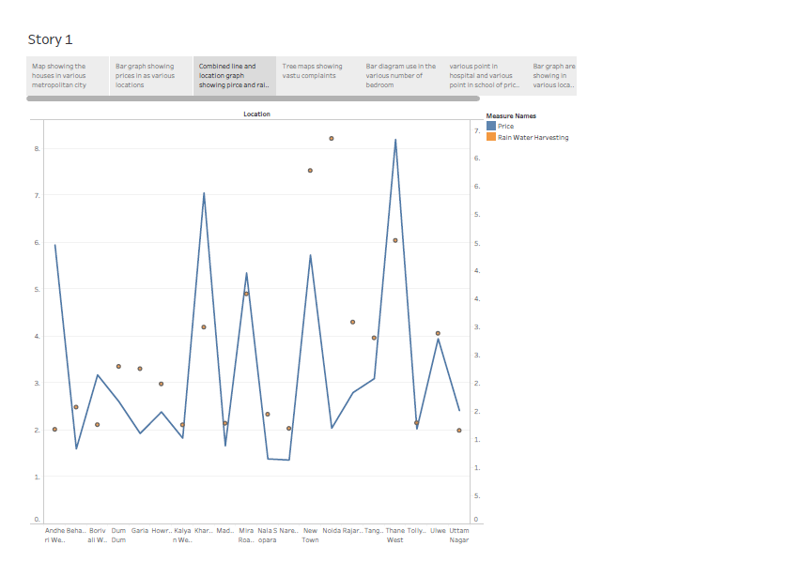

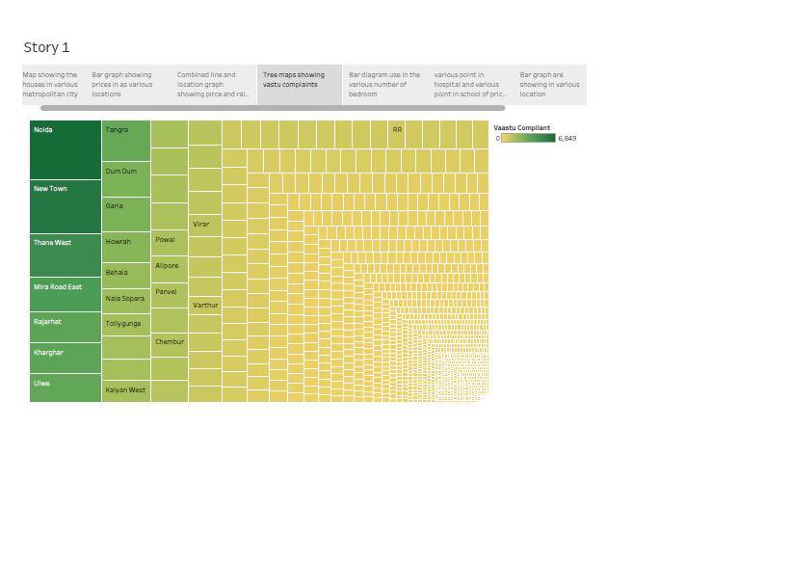

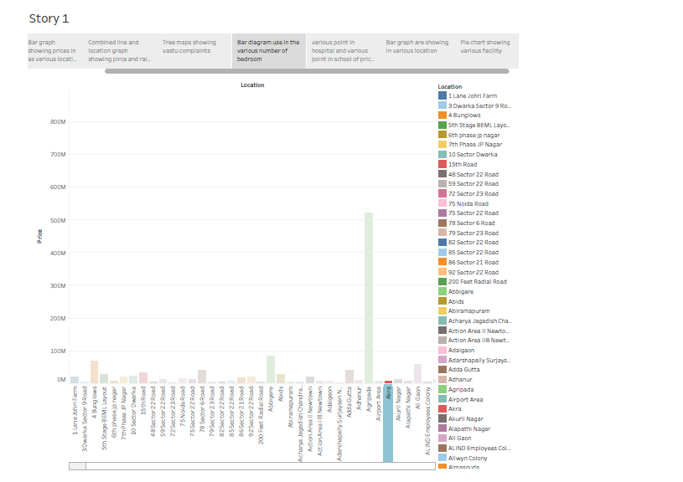

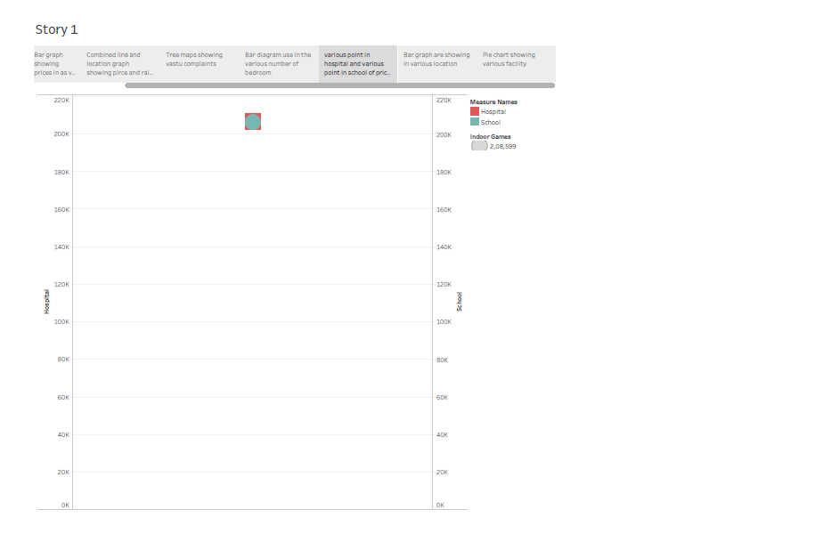

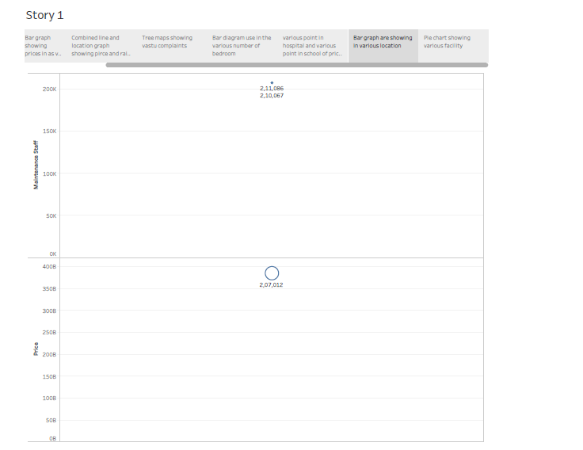

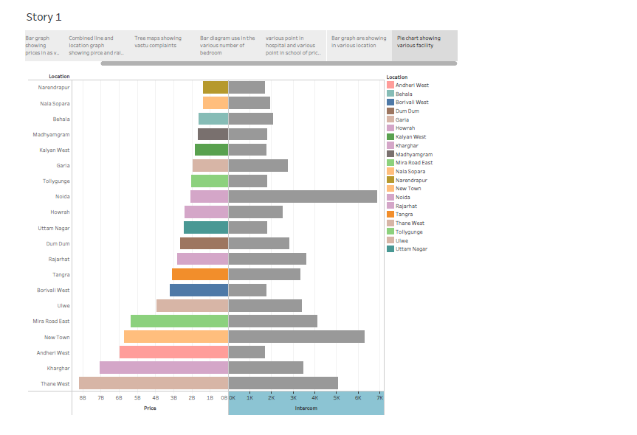



ADVANTAGES

1. **Market Insights:** This analysis provides valuable insights into the real estate market dynamics in metropolitan areas, helping individuals, investors, and policymakers make informed decisions.
2. **Investment Opportunities:** Investors and real estate developers can identify areas with potential for growth and make strategic investment decisions to maximize returns.
3. **Policy Formulation:** Government authorities can use this analysis to formulate policies related to housing, urban planning, and infrastructure development in metropolitan areas.
4. **Affordable Housing:** The findings can inform efforts to address housing affordability issues, helping policymakers devise strategies to make housing more accessible to a broader population.
5. **Urban Planning:** Housing price analysis assists in urban planning by understanding the demand for housing and its impact on the city's development.
6. **Risk Assessment:** Homebuyers and investors can assess the risks associated with property purchases or investments in specific areas, leading to more informed choices.
7. **Market Forecasting:** By identifying trends and patterns, analysts can make forecasts about future housing price movements, aiding in long-term planning.
8. **Economic Health Indicator:** Housing prices often serve as an indicator of the overall economic health of an area, with rising prices often associated with economic growth and stability.
9. **Demographic Insights:** Analyzing housing prices can provide insights into population growth, demographic changes, and urbanization trends in metropolitan areas.
10. **Environmental Impact:** Understanding housing demand can help identify areas that are at risk of urban sprawl, contributing to discussions about sustainable development.
11. **Public Awareness:** Publishing findings can increase public awareness and transparency regarding housing costs and market trends, which can empower citizens to make informed decisions.
12. **Sustainable Development:** By analyzing housing prices, urban planners and policymakers can work towards sustainable and inclusive urban development.

DISADVANTAGE

1. **Data Availability:** Obtaining reliable and up-to-date housing price data can be challenging. In some cases, data may not be readily available or may not cover all areas of interest.
2. **Data Quality:** Data quality issues, such as inaccuracies, missing information, and discrepancies, can affect the accuracy of the analysis.
3. **Regional Variations:** Housing markets can vary significantly from one metropolitan area to another, making it challenging to develop a one-size-fits-all analysis. Local nuances and dynamics need to be considered.
4. **Complexity:** Analyzing housing prices involves multiple variables, including location, property type, amenities, economic factors, and more. Managing this complexity can be time-consuming.
5. **Market Volatility:** Real estate markets can be subject to sudden changes and fluctuations, making it challenging to predict long-term trends accurately.
6. **Ethical Concerns:** Analyzing housing prices can sometimes raise ethical concerns, such as the potential for gentrification, displacement of lower-income residents, and property speculation.
7. **Privacy Issues:** Accessing certain property-related data may raise privacy concerns, especially when it comes to individual homeowners.
8. **Regulatory Changes:** Changes in government policies, tax laws, or other regulations can have a significant impact on the real estate market, making predictions more challenging.
9. **Data Bias:** Data may have inherent biases, such as sampling bias, which can skew the analysis results.
10. **Cost and Resource Intensity:** Comprehensive housing price analysis can be resource-intensive, requiring access to data, analytical tools, and expertise. Small organizations or individuals may face limitations in conducting in-depth analyses.
11. **Market Manipulation:** In some cases, housing markets may be subject to manipulation or speculative bubbles, which can distort price trends and analysis.
12. **Limited Predictive Accuracy:** While analysis can provide insights into current trends and correlations, predicting future housing prices accurately remains challenging due to the dynamic nature of the market.
13. **Data Interpretation:** The interpretation of housing price data can vary, and different analysts may draw different conclusions from the same data, leading to potential disagreements or misunderstandings.
14. **Time Sensitivity:** Housing market conditions can change rapidly, and timely data updates are essential to maintain the relevance of the analysis.
15. **Lack of Transparency:** In some cases, the real estate market may lack transparency, making it difficult to obtain comprehensive and reliable data.